How to make First Book your charitable organization with AmazonSmile

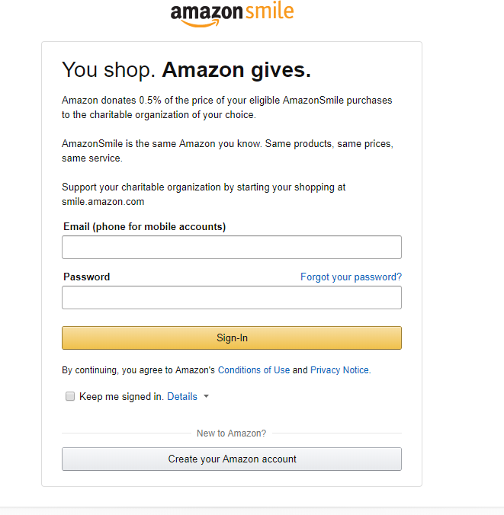
- Sign in to your Amazon account at smile.amazon.com on your desktop or mobile phone browser.

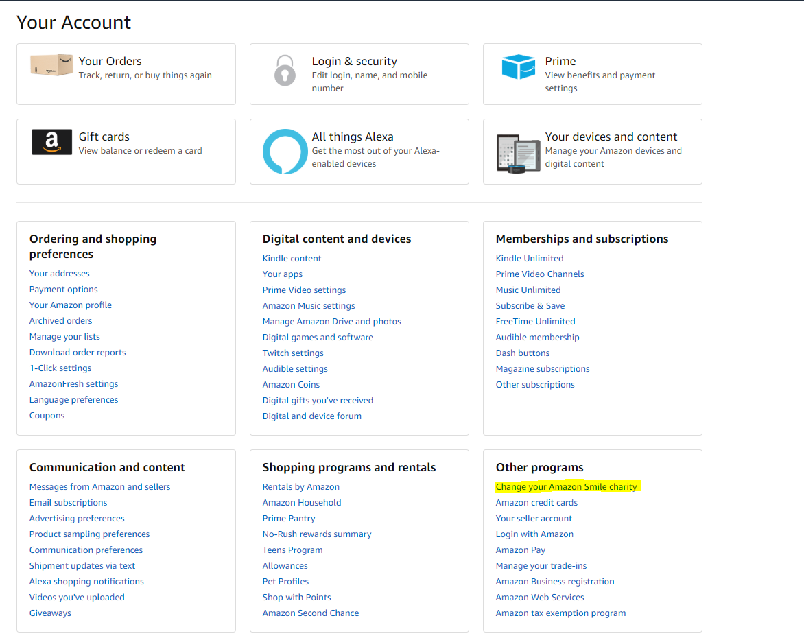
- From your desktop, go to Your Account from the navigation at the top of any page, and then select the option to Change your Charity. Or, from your mobile browser, select Change your Charity from the options at the bottom of the page.

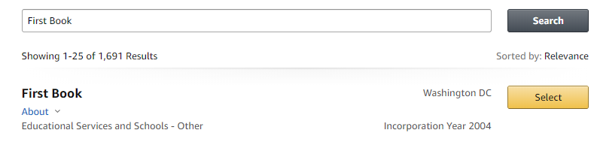
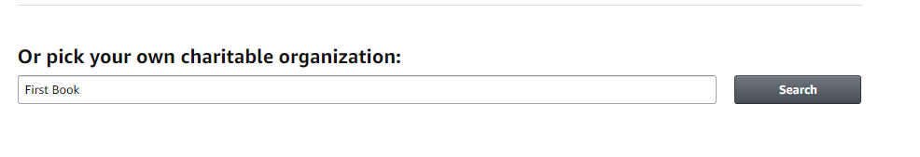
- Select First Book as your charitable organization to support.

- After you have selected First Book, you have successfully added us as your charitable organization. Thank you for your support!

